Creating Offer Templates
Objective
After completing this lesson, you will be able to create offer templates using merge fields to centralize the job offer process.
Job Offer Management
Effectively managing job offers is crucial for attracting top talent. SmartRecruiters streamlines this process by centralizing offer management within the candidate application. SmartRecruiters simplifies offer management by providing a centralized location within the candidate's application.
SmartRecruiters offers the following offer-related feature options:
- Companies can create personalized offers from templates that include offer clauses/additional paragraphs, send them via email or via an optional DocuSign integration, and monitor applicants' responses.
- For those with offer approvals in place, the offer creator can submit the offer for approval and track approvals.
- Offers can be approved sequentially or in parallel.
- Only users with full access to the job can send offers, view offer details, or view related messages. Hiring team roles on the job with write access for approvals can create and send offers.
- When the applicant responds, these users can either mark the applicant as hired or withdrawn.
- If DocuSign integration is enabled, the offer will automatically move to the hiring process step offer is accepted in the hiring workflow.
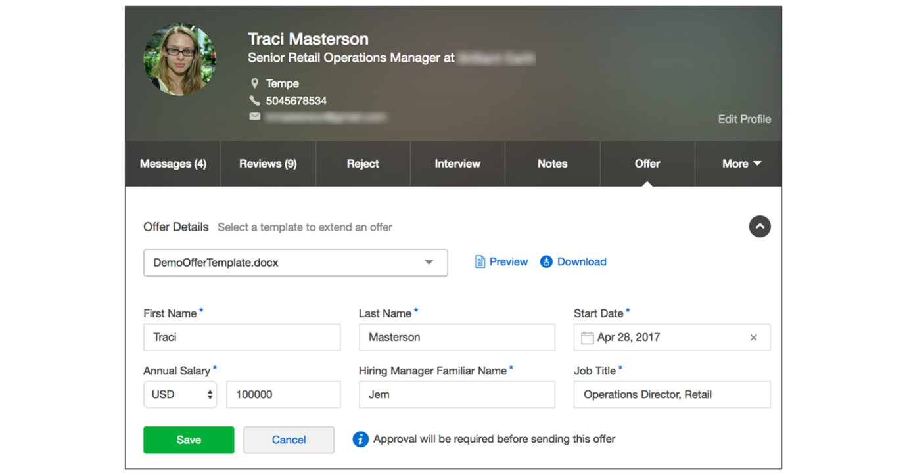
Key Features of Offer Letters and Clauses
Organizations can create and manage personalized job offers in SmartRecruiters by leveraging key features of offer letters and clauses, ensuring a consistent, efficient, and professional experience for both internal teams and candidates.
- Offer Templates: Offer templates are managed under Settings/Admin→Offer Templates. Offer letters are created externally (e.g., in Word) and uploaded into SmartRecruiters.
- Merge Fields: Use merge fields to pull values from your offer forms into your offer letters. These fields are enclosed in open and closed brackets. Copying and pasting merge fields is recommended to avoid errors.
- Application Fields: Application fields can be configured under Configuration→Application fields. These fields can be set to appear on the offer form, hire form, and candidate profile.
- Clauses: Clauses add flexibility by allowing you to include additional information in your offer letters based on specific criteria. For example, you can create a clause for a signing bonus that appears only if the candidate is eligible.
Note
The maximum number of clauses associated with an offer template is 20.
- Trigger Questions: Set up a trigger question for each clause. If the answer to the question is yes, the clause will be added to the offer.
- Code Snippets (for adding clauses): Add the provided code snippet into your offer letter.
Hint
Best Practice - Merge fields in offer letters come from application fields. Before creating offer letters, make sure all required application fields are set up and configured as merge fields. This includes deciding which application fields should appear in the Offer section of SmartRecruiters. SmartRecruiters already provides many built-in application fields, so always check for an existing field before creating a new one.
Do not make application fields mandatory in the offer section. The merge fields that need to be completed will automatically become mandatory if configured in the offer letter template.
Create an Offer Template with Merge Fields
Steps
- Create the offer template file.
Create a new offer template using a supported text editor format:
  - DOC
  - DOCX
  - ODT
Hint
Best Practice - Use DOC or DOCX to avoid formatting issues.
- Identify candidate-specific information.
  - Identify all the information that should be customized for each candidate, such as:
    - Salary
    - Office location
    - Stock options
  - On your current offer forms, mark this information with square brackets (e.g., [Salary]), so it is easy to identify for the next steps.
- Confirm application and job fields.
Since you're creating a single template to make offers for multiple candidates, you'll need to include placeholders for candidate-specific information. To do this, you can insert merge fields into the offer text.
  - Ensure the merge fields are generated from existing application fields and job fields in your SmartRecruiters account.
  - Set up all required application fields and job fields before building the template to avoid rework later.
- Review available merge fields.
Once you have all the necessary merge fields, replace each input field in the template with its corresponding merge field.
  - Review the list of existing merge fields created by a Super User or Admin.
  - Go to Settings→Offer Templates→Merge Fields and Instructions.
  - Confirm there is a merge field for each piece of candidate-specific information identified earlier.
- Create missing merge fields (if needed).
  - If a required merge field does not exist, create a new application field or job field.
  - Once created, the new field will become available as a merge field.
  - Replace each input field in the template with its corresponding merge field.
Example merge fields in an offer letter:
Code Snippet
Copy codeSwitch to dark mode
<<OfferLetterDate>>

Dear <<ApplicantFirstName>>,

We are pleased to offer you the position of <<JobTitle>> with a
starting date of <<StartDate>>.

Your annual salary will be <<AnnualSalary>> and you will report to
<<HiringManagerFamiliarName>>.

Please indicate your acceptance by signing below.
Offer Template Creation Tips and Tricks
- Avoid using floating objects, as they may be repositioned incorrectly during document conversion.
- Minimize heavy styling and formatting; remove unnecessary formatting where possible.
- Create templates using new Word documents rather than reusing older files.
- Ensure anchor text is locked to the correct text line.
- Avoid copying and pasting content from older templates, as hidden formatting may carry over.
- Accept or reject all tracked changes before uploading the document.
- Pro Tip: If adding DocuSign merge fields (anchor text) for signatures or initials:
  - Insert them in black text.
  - Change the text color to white so they do not appear in the offer letter.
  - DocuSign will still recognize the fields and place the required signature blocks automatically.
Upload an Offer Template
Steps
- Navigate to Offer Templates.
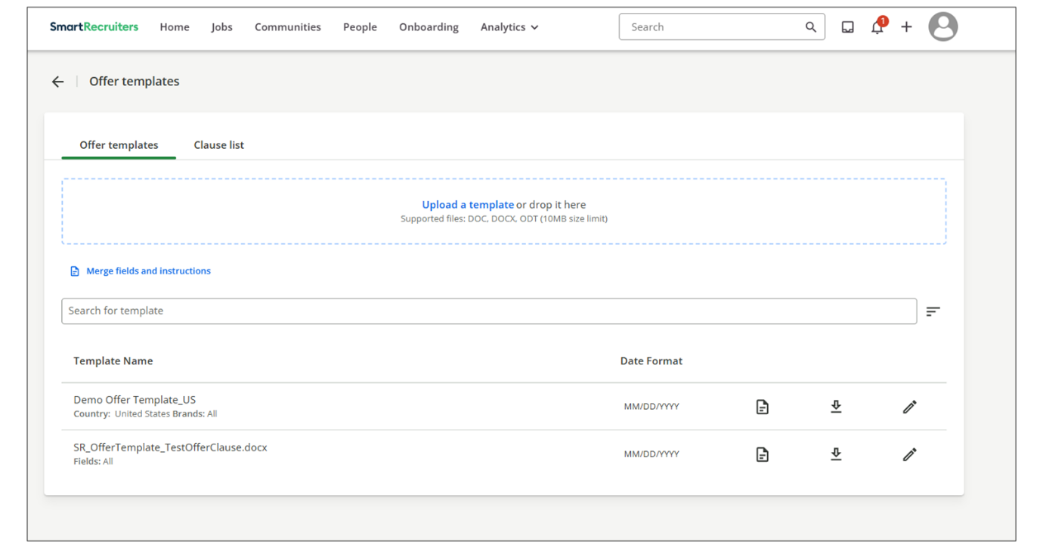
- Select Upload a template.
- Select your template to upload.
- Once the template has been uploaded, select the page icon to preview it.
- If you encounter errors, they are usually caused by missing clause values or application fields that either do not exist or are not visible on the offer form. To fix this, delete the template, update the original document, and then re-upload it.
Note
Offer templates containing OLE Objects will not be processed when uploaded. This measure is being implemented to ensure the highest level of security and to protect our users from potentially malicious documents. If you encounter difficulties uploading an offer template or generating offers due to this restriction, please check your document for any embedded OLE Objects and remove them before re-uploading.
- Once you've uploaded the template, set the date format or make it available to specific jobs by selecting the Edit icon.
  - To make the offer template available on any job, leave All for each Org field in the list.
  - To make it available for specific jobs, choose different values for one or more fields.
Note
Set it to Day/Month/Year unless the offer letter template will be used in the US. US offers use flexible dates to avoid binding contracts and manage background check delays.
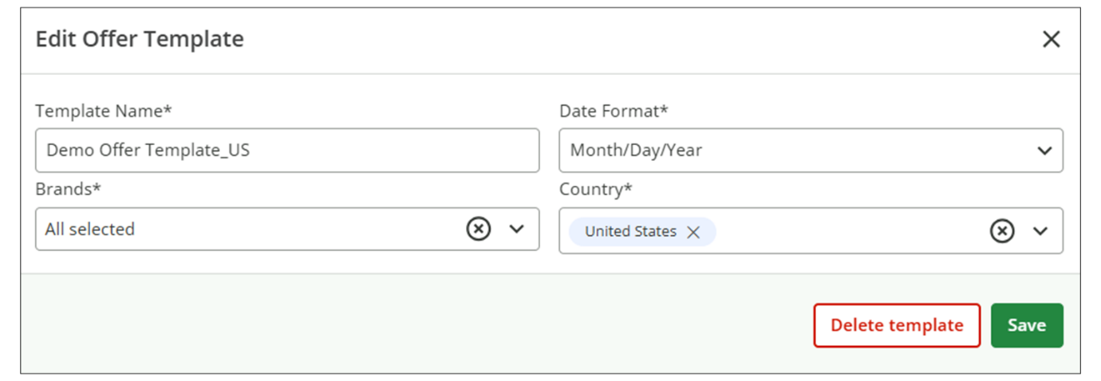
Offer Template Limitations
Offer template names are limited to 400 characters. Because filtering options are basic, such as alphabetical order, recent activity, or keyword search, it's recommended to use a clear and consistent naming convention to make templates easier to find and manage.
When updating offer templates, you may need to temporarily hide a version from users until it is officially ready for use (e.g., during a Hire Sync update). This can be done by assigning the template to a country that is not currently used.
There is no limitation on the number of candidate fields. However, when creating the Word template, make sure headers and images are sent fully to the back, not just sent backward, to avoid layout issues.
When working with clauses, always paste clause snippets using keep source formatting or text only to prevent formatting problems. Remove duplicate content and delete any unnecessary No options.
Be aware of file size and quantity limits. The maximum file size for an offer template is 2 MB. Each offer template can include up to 20 clauses, and each clause must not exceed 30 KB. The combined size of an offer template and its clauses must also stay within 2 MB limit.
Watch the video below for more details about creating an offer.
This video is for demonstration purposes. Any references made in this video to previous or later videos in this course (including titles, numbers, links, or sequence) may differ from the current course structure. Additionally, some functionalities shown may have evolved over time due to ongoing enhancements or business decisions.
Summary
- SmartRecruiters centralizes offer management within the candidate application, streamlining the process of creating and sending personalized job offers.
- Admins can create and upload new offer templates using various text editor formats and upload them to SmartRecruiters.
- Merge fields are used to include candidate-specific information in offer templates, ensuring each offer is personalized.
Hi, in these videos, we're going to review SmartRecruiters Offer Management. SmartRecruiters places the
entire offer management process in one place on the Offer tab
of the candidate application. Companies can create personalized
offers from templates, which can include offer clauses,
additional paragraphs, and send them either email or an optional
DocuSign integration. You can also monitor the candidate
responses within the system. For those with offer approvals
in place, the offer creator can submit the offer for
approval and track approvals. In this video, we will
review creating an offer on an application, and
in the following videos, we'll review creating an
offer containing clauses, creating the offer letter
itself, how to create a clause, and creating and sending
an offer through DocuSign. Once you're ready to extend
an offer to an applicant, you can go ahead and access the
people list on the job and the applicant that you're
looking to extend that offer to. For this example, I've gone
ahead and I've clicked the offer bucket, which is going to
filter my candidates by offer stage, and I'm ready to extend
an offer to this applicant. Once you're on the application, you can go ahead and click the offer form. You'll be presented with an option
to select an offer template. For this example, I'm going to
use this HL Solutions offer, which is an offer template that I've
configured on the Settings panel. But you also can upload a custom
template on the application itself. When the template is selected, your
pre-configured candidate fields that are set to appear on the offer
form are going to fill in, and it's going to pull in those values
based on the candidate profile. So, for example, Keeley's first name is pulled in
because it's part of the profile. However, there are other
fields such as annual salary and start date that's going
to ask the user to fill in. We'll go ahead and fill in the annual salary as well as picking a start date. Any other fields that
are marked on the offer form, you'll also want
to fill in as well. Once you're happy with the offer
details, you can save. Once the offer is saved, you'll be presented with
the option to preview the offer. This will be an example
of what the candidate will see when the offer is extended. And you can refresh the offer date. which will refresh the offer
date to today's date. When you're ready to send out
the offer, you can go ahead and send the offer via email, and
the candidate will receive it. Thank you.

Working with Offer Clauses
Objective
After completing this lesson, you will be able to create Offer Clauses to customize offer templates and generate accurate offers.
Offer Clause Management
Clause management in SmartRecruiters' Offer letters provides the primary benefit of standardizing offer documentation while maintaining necessary flexibility. Instead of creating each offer from scratch, recruiters can use a centralized library of pre-approved legal and business clauses (e.g., standard compensation terms, non-disclosure agreements, relocation packages).
This ensures that every offer letter is legally compliant and consistent with company policy, mitigating risk. At the same time, recruiters can dynamically insert or swap out variable clauses based on the job, candidate type, or location (e.g., a severance clause for an executive role versus a standard clause for an entry-level position). This combination of standardization and composability dramatically accelerates the offer creation process and allows the hiring team to focus on content accuracy rather than legal phrasing.
Create an Offer Clause
Create the clauses in Microsoft Word or OpenDocument Text (ODT) format. Make sure they use the same formatting and styles as your existing offer templates. Clauses can also include merge fields if needed.
Steps
- Navigate to Settings.
- Select Offer Templates within the Template section.
- Choose the Clause List tab.
- Select Create New.
- Add a title, description, and clause ID label.
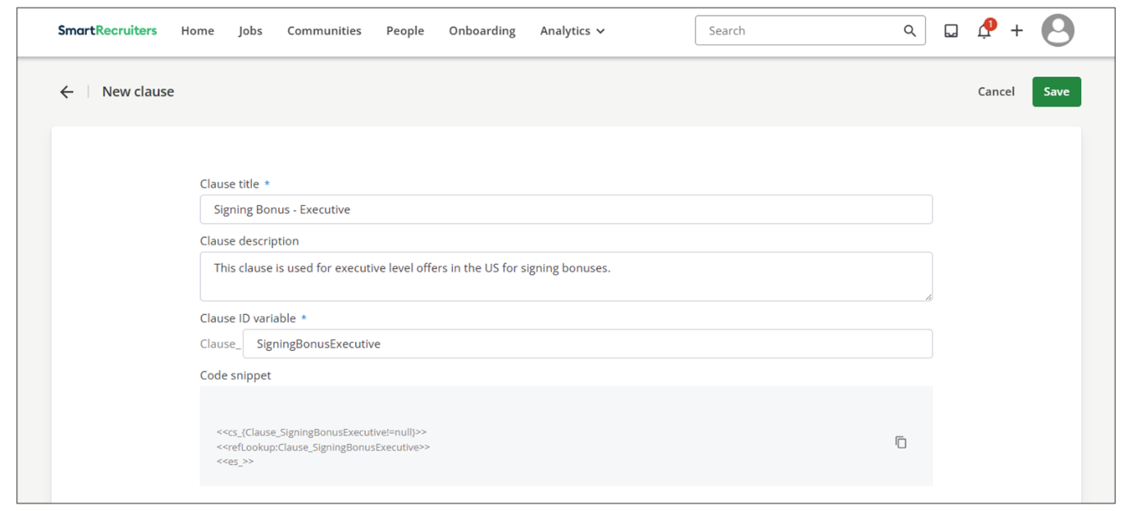
- Add a trigger question that asks the user whether this clause should be included in the offer. The user’s answer determines if the clause is added automatically.
For example, if the trigger question is Is this candidate receiving a signing bonus? and the user selects Yes, the signing bonus clause will be inserted into the offer template automatically.
- Select Add Value to create response options for the trigger question. These options allow the user to choose which clause is inserted into the offer. If there are multiple versions of a clause, you can add multiple values, each linked to a different clause.
- Select no clause value if you do not want the clause to appear at all in the document.
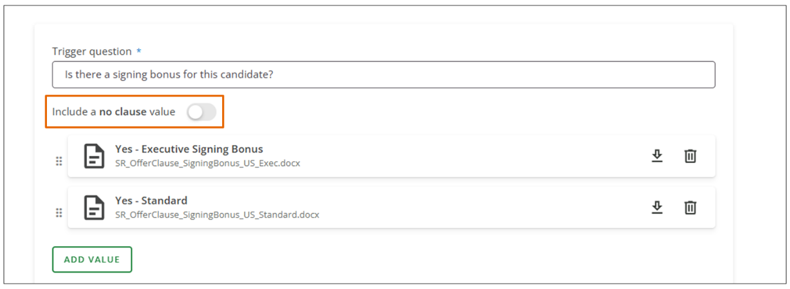
- Select Save.
- Copy the Code Snippet to add to the offer template where the clause should be inserted.
Code Snippet
Copy codeSwitch to dark mode
<<cs_{Clause_SigningBonusExecutive!=null)>>
<<refLookup:Clause_SigningBonusExecutive>>
<<es_>>
Add an Offer Clause to an Offer Template
Once the offer clause is created, it must be added to the appropriate offer template.
Steps
- Open the offer template where you want to add the clause.
You can open a local file (e.g., a Word document).
- Insert the code snippet for the clause into the correct location in the offer template.
- Save the updated template.
- Upload the offer template to SmartRecruiters.
Use Offer Clauses When Creating an Offer (End User)
Steps
- Select an offer template as part of the standard offer creation process.
- If the template includes clauses, answer the questions in the Make clause selections section.
- After answering the questions, the system loads the Offer details section, including:
  - Merge fields
  - Offer approval fields
- Complete the required fields and continue to finalize the offer.
Best Practice
SmartRecruiters allows a maximum of 20 clause values per offer letter. If you need more than 20 values (for example, 30), split them across two separate clauses.
For example, place 15 clause values in the first clause (plus a No clause value option) and the remaining 15 clause values in a second clause (also with a No clause value option).
In the offer template, insert both code snippets. When creating an offer, select the appropriate clause value for one clause and select No clause value for the other. This ensures only the correct clause is applied.
Watch the video below for more details about creating offer letters and clauses.
This video is for demonstration purposes. Any references made in this video to previous or later videos in this course (including titles, numbers, links, or sequence) may differ from the current course structure. Additionally, some functionalities shown may have evolved over time due to ongoing enhancements or business decisions.
Summary
- Offer clause management provides a centralized library of pre-approved legal and business terms, allowing recruiters to standardize documentation while maintaining the flexibility to customize offers for specific roles or locations.
- The system uses trigger questions to determine which clauses are included; when a user selects a specific response value or Yes, the corresponding clause is automatically inserted into the offer template.
- To integrate these dynamic elements, admins must copy a unique code snippet from the clause configuration and paste it into the appropriate location within a Microsoft Word or ODT offer template before uploading it to the system.
- For complex requirements, the system supports up to 20 values per clause; if more are needed, best practice suggests splitting them across multiple clauses and using the No clause value option to ensure only the relevant content is displayed.
Hi, in this video, we will review offer templates and offer letter creation. Your offer templates can
be managed under Settings/ Admin, Offer templates
under the Templates section. In this setting, you'll see a list
of your available offer letters. Offer letters themselves
are created outside of SmartRecruiters and
uploaded into the system. You can use a system such as Word
to create your offer letters. One of the things we'll
call out during offer letter creation is the use of
merge fields, which are actually candidate fields
converted into merge fields. These merge fields are going
to pull values from your offer forms into your offer
letters, which will then populate when creating an
offer letter and the candidate will be able to see the
values that you've created. As you can see, we've gone
ahead and selected a number of merge fields within the
offer itself. Merge fields can be found under the C
merge fields and instructions. When creating an offer letter,
it's important to note that merge fields will only work if you're
containing the open and closed bracket. A best practice is to use
copy and paste when adding merge fields into your offer letter.
All of the merge fields that you create will appear on this list, and
any custom fields that you create will appear on this list as well.
To create a merge field, we'll want to go to a different setting,
and that's Candidate fields. Candidate fields can be created to
pull values into different areas of the system, such as the offer
form, the hire form, and the candidate profile. You'll want to go under
Configuration candidate fields. If you wish to configure a candidate
field, you can either choose from the existing fields that are in your
system, or you can create a custom field. And when creating a custom
field, you can select where that field's going to appear. In our
example, if we're looking to have a merge field appear on an offer form,
we'll want to have it selected. And once you go ahead and save that
merge field, you'll then see the merge field appear on your merge field
list. I've gone ahead and configured a number of candidate fields. If
I go back to our offer template settings, we will have those merge
fields available under custom fields. Now that I've added my merge
fields, I can save this offer letter and upload it into SmartRecruiters.
The offer letter uploaded successfully, and I expect to
see the offer letter available when choosing an offer to select
on a candidate application. Now let's look at creating
offers with a use of a clause. A clause adds additional flexibility
for your hiring team to add additional information into your
offer letters. For example, let's say your new hire is eligible for a
signing bonus and you want to create an additional clause for that
rather than a completely different offer letter itself. What you can
do in the clause creation is create a title, you can add a description
if you wish, and then set up a trigger question. For this
example, the trigger question happens to be, does this candidate receive
a signing bonus? If you answer yes, then you will have the
additional clause appear in your offer creation. What you want to do as
well is take this code snippet and add it into your offer letter. That
way, if the trigger question is answered as yes, then the system
will know to add the clause if the trigger question is answered. We'll
go ahead and save this offer and add it to our offer template
list. Now that it's been added successfully, we can go ahead and make
an offer using the new clause. We'll navigate to the offer section,
select the offer with the clause, select that there's a signing
bonus, which will then add the clause to the offer,
proceed with the offer details, save the offer. You can preview
the offer beforehand and notice that the clause has
been added to the offer itself. Once you're happy with the offer,
you can send it to the candidate.
Integrating Offer Templates with DocuSign
Objective
After completing this lesson, you will be able to integrate DocuSign offer templates to automate electronic signatures and expedite the finalization of hires.
DocuSign Integration for Offer Letter Templates
Integrating DocuSign dramatically reduces the time it takes to finalize a hire. Recruiters can trigger the offer letter from within SmartRecruiters and send it to the candidate for review and e-signature on any device. This speed is crucial in a competitive talent market, helping organizations secure top candidates before they accept a competing offer.
SmartRecruiters integrates with DocuSign to facilitate electronic signatures on offer letters, creating the following streamlined process for recruiters and candidates:
- Setting up DocuSign Templates: Add DocuSign fields (such as signature fields and date fields) to your offer templates. These fields can be found in the SmartRecruiters Help Center. A best practice is to make the text white so that only the signature icon is visible.
- Sending via DocuSign: Users with a DocuSign license tied to their SmartRecruiters account will see the option to Send with DocuSign.
- Reviewing and Sending: You'll be directed to the DocuSign interface, where you can review the offer, add additional fields if needed, and then send it to the candidate.
- Candidate Experience: The candidate receives an email notification and can review the document and add their electronic signature.
Create Offer Templates for the DocuSign Integration
Admins can create new templates for sending offers via email using various text editor formats. Acceptable file types are .DOC and .DOCX (Microsoft Word), and.ODT files used by LibreOffice and other open document standards.
Note
Google Docs documents can be converted into .DOCX and .ODT. PDF documents cannot be accepted.
To save time later, add DocuSign anchor text (in white font) to the templates. DocuSign will recognize this text and insert fields into the offer to collect signatures, initials, dates, and more from candidates or executives.
Since you're creating a single template to make offers for multiple candidates, you'll need to include placeholders for candidate-specific information. To do this, you can insert merge fields within the text of the offer. These are generated by SmartRecruiters based on the candidate and job fields in your account. You can only choose from the list of merge fields that is available in your SmartRecruiters account.
Steps
- Use a document editor (e.g., Word) to create the offer letter template.
- Identify all the information that should be customized for each candidate. These are input fields such as salary, office location, and stock options.
- Check your list of custom merge fields to make sure there is one for each input field.
- Find your list of merge fields. If there are any missing, create a custom candidate field first.
- Add merge fields.
- Replace each input field in the template with its corresponding merge field. To add a merge field into the template, use this format:
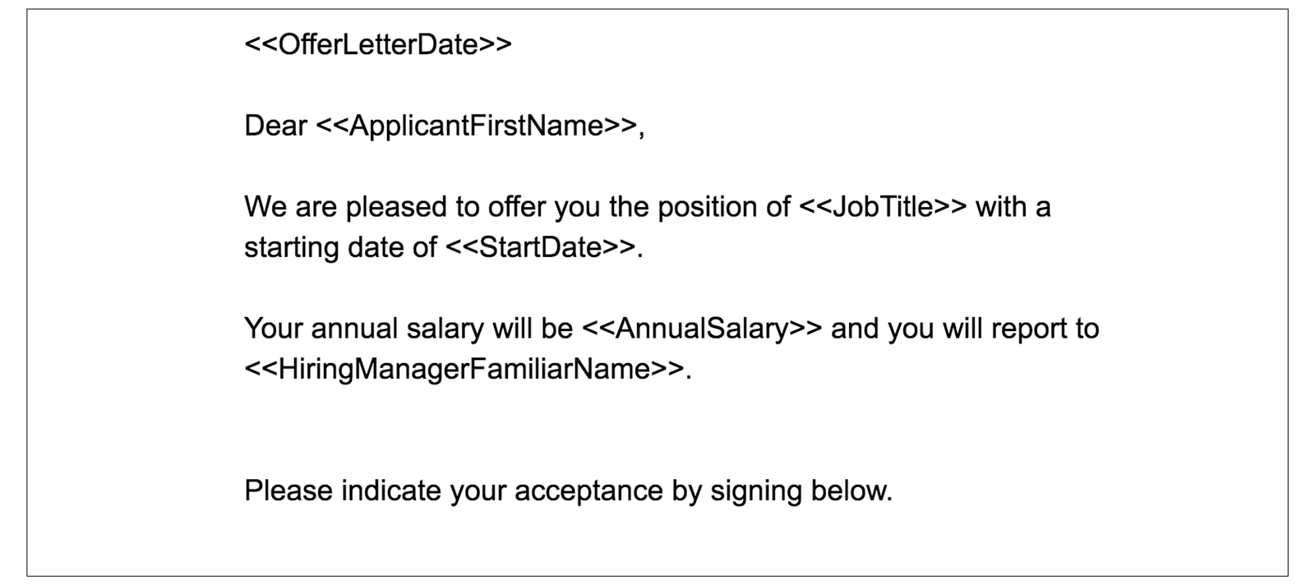
- Add DocuSign fields to the template.
  - To automatically place DocuSign fields for candidates or executives, you can add specific anchor text to the Microsoft Word template. When DocuSign generates the offer letter for preview and signature, it will automatically detect the anchor text and place the fields.
  - There are two sets of anchor text for offer templates, one for candidates and one for executives:
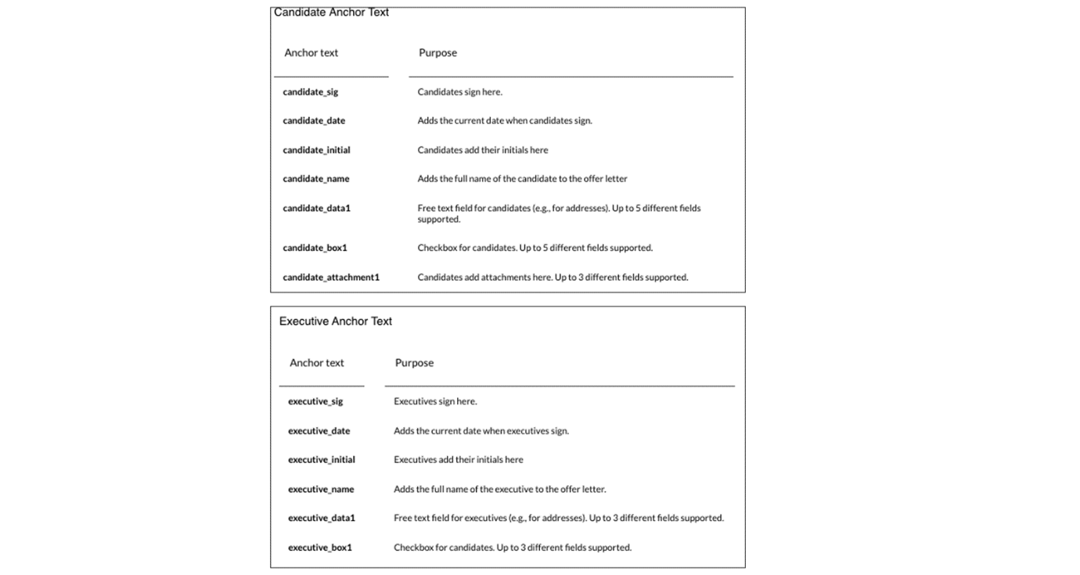
- Add DocuSign fields for candidate and executive signers by adding the appropriate anchor text to the template. For example:
  - Add candidate_sig where a candidate needs to sign.
  - Add executive_sig where an executive needs to sign.
Note
No special formatting is required. Simply enter the anchor text into the Word document and change the anchor text's color to white to prevent it from appearing in the offer.
Note
In the example below, the white text is surrounded by a grey highlight for contrast.
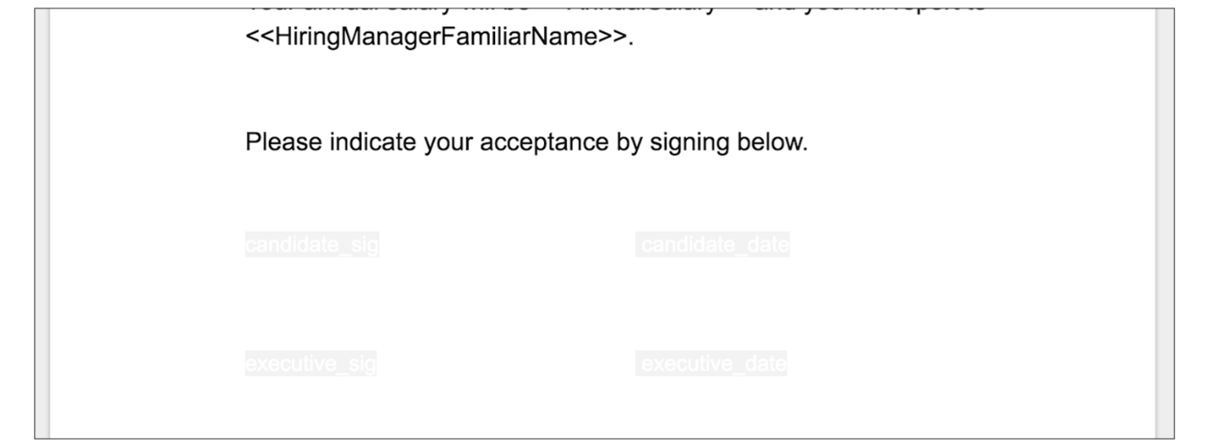
Hint
Best Practice - When integrating DocuSign with SmartRecruiters, use a dedicated service account for the integration. If the integration is tied to an individual user account and that user leaves the organization, the associated email address may be deactivated, causing the DocuSign integration to fail.
Upload the DocuSign Offer Template
Once you have created your template, you can activate the template by uploading it to SmartRecruiters.
Steps
- Upload the template within Settings→Offer Templates.
- Select Upload Template.
- Select your template.
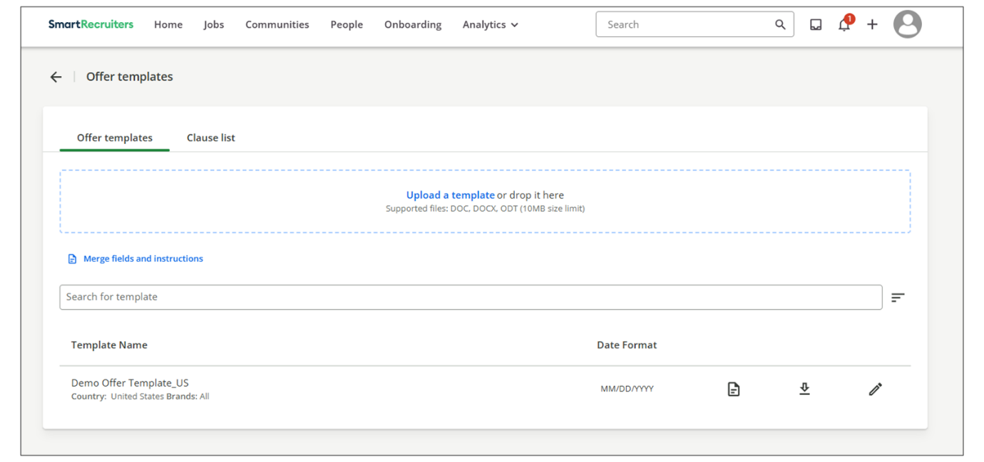
- Select the pencil icon to assign the offer template to specific org fields.
  - To make the offer template available for all jobs, leave All selected for each org field.
  - To make the template available for specific jobs only, select specific values for one or more org fields. You can select multiple values within each field.
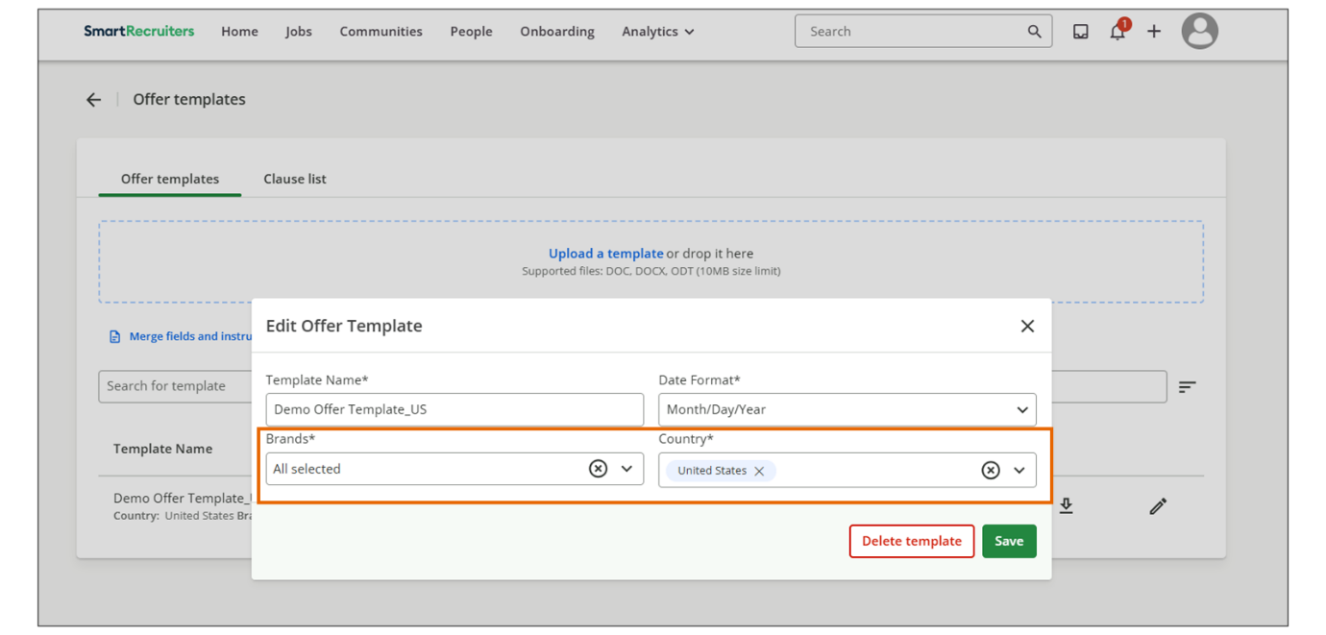
- Select the letter icon next to the new offer template to preview it.
  - If there are errors, delete the template, edit the original file, and upload it again.
  - Once you've uploaded the template, you can set the date format or make it available to specific jobs by selecting the Edit icon.
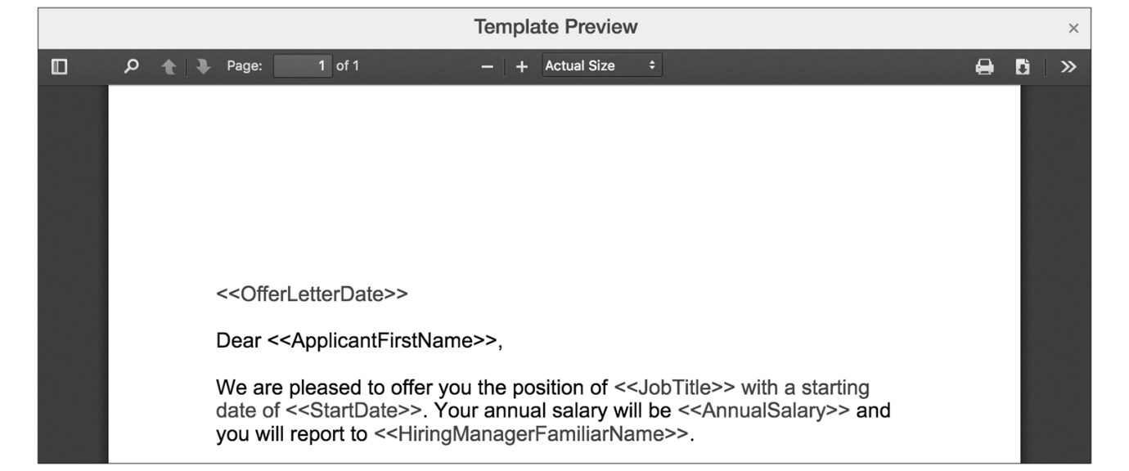
Result
When the template is used to create an offer, DocuSign will automatically detect and fill in the anchor fields:
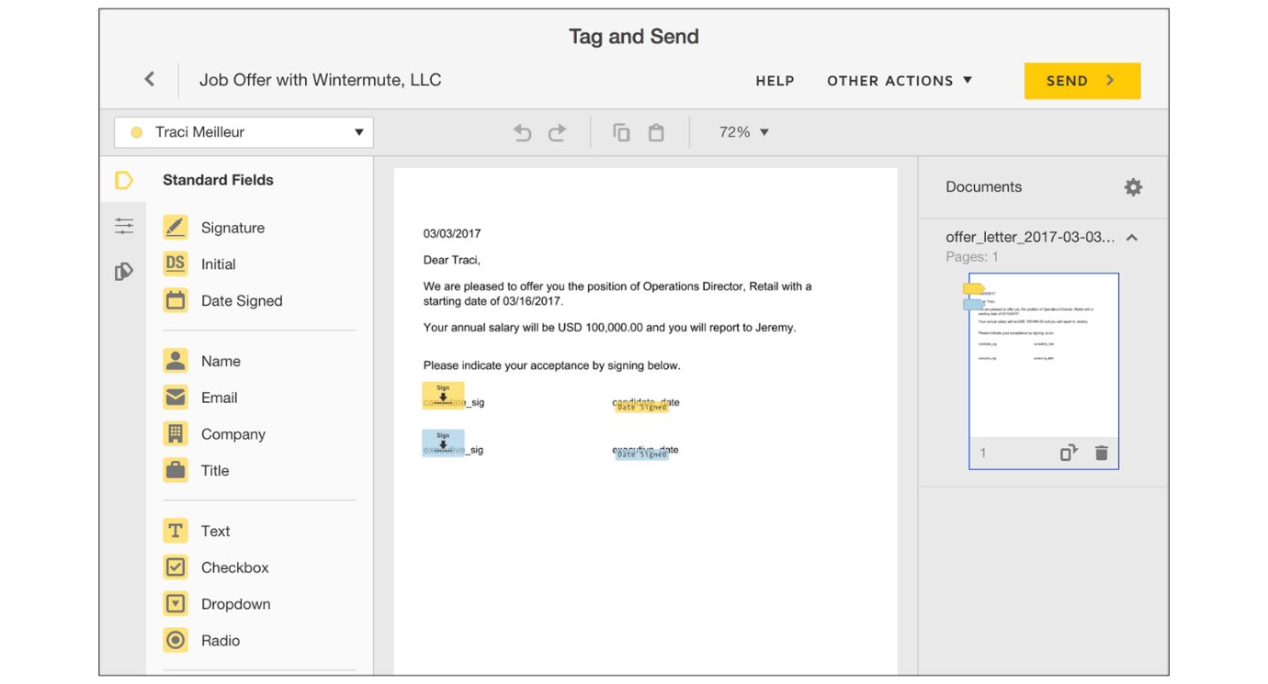
Note
Use the SmartRecruiters Offer Accepted hiring process step, as it is integrated with DocuSign when an applicant accepts the offer via DocuSign.
Learn more about creating offers using DocuSign by watching this video.
This video is for demonstration purposes. Any references made in this video to previous or later videos in this course (including titles, numbers, links, or sequence) may differ from the current course structure. Additionally, some functionalities shown may have evolved over time due to ongoing enhancements or business decisions.
Summary
- Integrating DocuSign with SmartRecruiters streamlines the offer letter process by enabling electronic signatures.
- Recruiters can trigger offer letters from within SmartRecruiters, sending them instantly for candidates to review and sign on any device.
- DocuSign anchor text can be added to offer templates to automatically place fields for candidates or executives to sign.
- Acceptable file types for offer templates include .DOC, .DOCX, and .ODT.
- Users with a DocuSign license tied to their SmartRecruiters account will see the option to Send with DocuSign.
Hi, in this video, we're
going to review Creating an offer with DocuSign fields, as well as sending an offer through
the DocuSign integration. In our previous video, we
walked through the steps of adding merge fields to
offer templates and then uploading those offer
templates into the system. Much like setting up a normal
offer template, the DocuSign template has additional
candidate fields that you would add that are going
to pull in different fields from the DocuSign integration,
such as signature fields. Those fields can be found in
our help center knowledge base. There's an article called Create
Offer Template for DocuSign that you can use to assist with
setting up your offer templates. But down below, there's a
list of these different merge fields that you can use as part
of the DocuSign integration. For this example, I've gone
ahead and I've added candidate signature and candidate date
to my existing offer template. As a best practice, SmartRecruiters recommends making the text white. That way,
when the DocuSign integration runs, you don't happen
to see the candidate's signature text, but rather
you just see the icon to sign. I'll go ahead and do that. Now, for this example, I've already
gone through and uploaded the template to the system itself,
and I have an offer ready to go. For this candidate, I've
already selected the offer template that I've updated
containing the DocuSign fields, as well as filled out the
offer details that I need to. Now, users that are part of the
DocuSign integration, meaning that they have a licensed seat as part
of the integration tied to your account, will see the option to
send the offer through DocuSign. When I go ahead and click
Send with DocuSign, I'm presented with the offer email
that goes to the candidate. Here I can add additional
attachments. You can set a signing order, so if you happen to have
more than one signer on an offer, you can arrange the order you
wish for them to be signed, and you can create the email that you
want to send to the candidate. If I go ahead and click
Next, then I'm taken to the DocuSign side of the integration. Once on this page, I'll be
able to review the offer and add any additional fields as
part of the DocuSign integration. But if you scroll down
below, the merge fields that I added from our help center
are embedded into the offer. When I'm ready to move forward, I can go ahead and send this to the candidate. When the offer was extended
successfully, you will see on your application that the
offer was sent via DocuSign. From a candidate's perspective,
they will receive an email stating that they received a
job offer, and when they open the email, they have the option
to review the document. Once they acknowledge they're ready
to use the electronic signature, they can proceed and add
their signature as they wish. Thank you.

Creating Offer Approvals
Objective
After completing this lesson, you will be able to configure offer approval workflows.
Offer Approval Configuration
Offer approvals are a critical component of a well-managed hiring process. They provide a mechanism for oversight, ensuring that offers align with company policies and budget constraints. SmartRecruiters offers flexible options for configuring offer approval chains, enabling you to tailor the approval process to your specific organizational structure.
SmartRecruiter’s job approval workflow has three phases: request, approve, and extend the offer. Admins can set up a single company-wide approval process for all offers, or different approvals for offers on specific jobs, brands, and more.
As with many features, admins can assign approvals to specific job groups by selecting a set of values for the company's active org fields. SmartRecruiters applies the approval chain to any jobs that have the same set of values for these org fields.
When someone creates an offer that is subject to approvals:
- SmartRecruiters notifies the chain's approvers through a summary email. Approvers can then review details and approve from the email, or log into SmartRecruiters to approve.
- Offers requiring approval cannot be sent to the candidate until approved.
Create an Approval Workflow
To create a new approval process:
Steps
- Navigate to Settings.
- Select Offer Approvals in the Configuration section.
- On the Offer Approvals page, select New Chain.
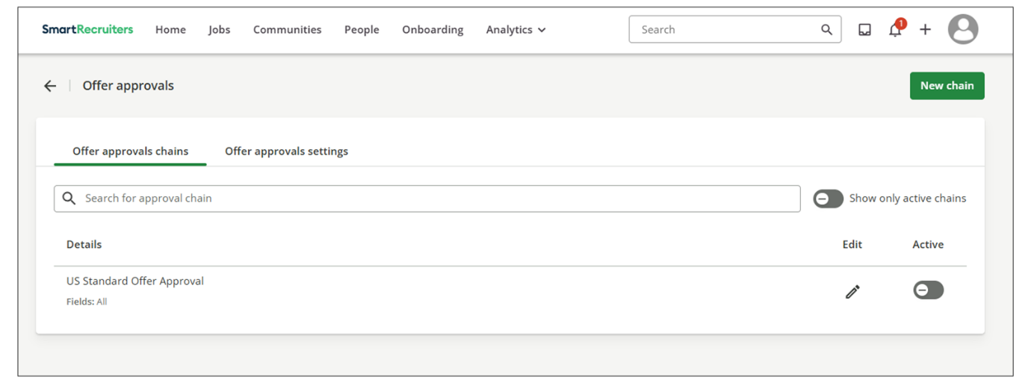
- Give the chain a name.
Hint
Using clear naming conventions is essential for organizing multiple approval chains within your instance.
- Select values for your active org fields to assign the chain to jobs. This allows you to allocate different approval chains to different jobs within your system.
For instance, you can set up one approval chain for offers in the marketing department and another for offers in the engineering department. If you want the approval chain to apply to all org fields, you can specify that as well. However, it's important to ensure that as more approval chains are created, they are uniquely applied to different areas within your organization.
  - To set up a global chain that applies to offers for all jobs, leave All for each field in the list.
  - To set up a chain that applies to offers on only some jobs, choose one or more values for each org field.
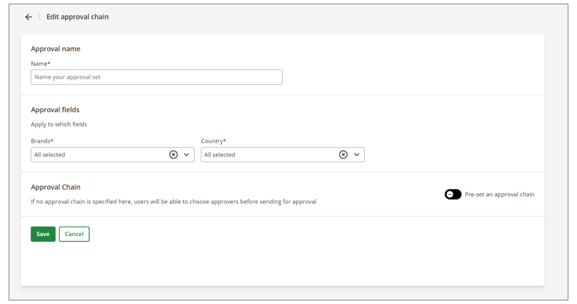
- Set approval chain.
Approval chains come in four types:
  - Per-job chain: Allows job creators, such as hiring managers and recruiters, the ability to choose approvers for each offer.
  - Parallel chain: Multiple approvers can approve the offer simultaneously.
This can expedite the approval process as users will be able to approve in their own time
  - Sequential chain: Approval requests are sent in a specific order. Each approver in the chain must approve the offer before it moves to the next approver.
Note
This can be useful if earlier approvers are likely to reject as later approvers will not be notified.
  - Integration chain: If you're using external integration for offer approvals, you can select this option.
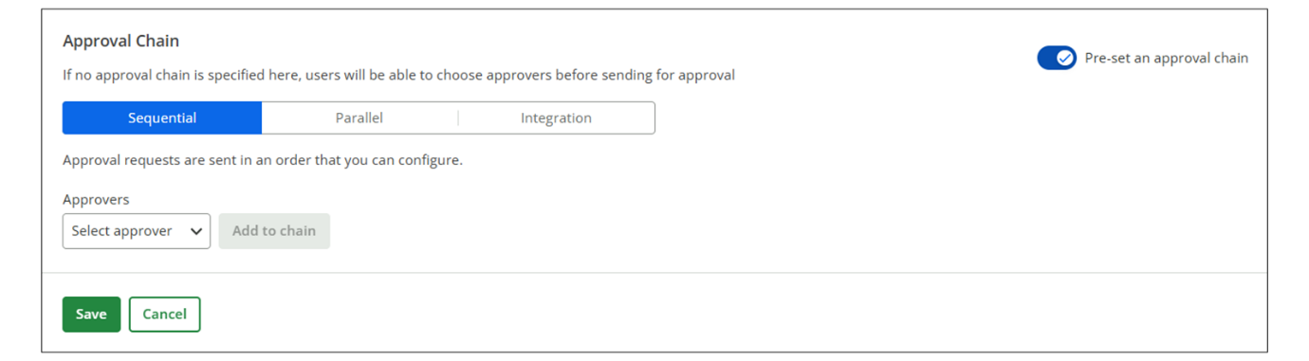
- Add Approvers to the chain by selecting Select an Approver.
  - If you choose Hiring Manager, Recruiter, Executive, or Coordinator, any user on the hiring team with that role will become an approver.
  - Choose named users to include specific individuals within the organization.
  - Choose Named user to designate a specific user by name. This user does not have to be on the hiring team. The user will be prompted to identify the approver when submitting for approval.
- Select Save. The saved approval chain will appear in the Details list.
- Return to the Offer Approvals page and use the Active switch to enable the offer approval chain. Once activated, the approval chain will apply to all relevant offers based on the organizational fields you specified.
Additional Offer Approval Settings
The offer approval settings also include several additional options:
- Approver Access to the Offer: This setting determines whether approvers retain access to the offer after it is approved. When this option is toggled on, it removes an approver's access to the offer after it is approved.
- Approver on the Offer: This setting allows approvers or an admin to delegate approval to another user. This is useful when an approver is unavailable.
- Authentication Setting: This setting determines whether users must be authenticated in SmartRecruiters to access the offer approval.
Note
These settings can be toggled on or off as needed to customize the approval process.
Hint
Best Practice - Have users who approve offers and jobs use the Delegate approvals option if they will be out of the office. Delegate approvals can be found by clicking Settings→Delegate approvals.
Offer Approval Workflow Management
When you extend an offer, the offer approval chain will be automatically applied. You'll see a third step in the offer process for setting up the offer approval. The system will pull in the approval chain that you recently configured, and the named user will be the expected approver.
Skip Approver
In the case where an approver is not available, an administrator can skip one or more approvers on a job or offer to help hiring teams move forward. Here is an example:
- The recruiter notices that an offer approver is out of the office and informs the administrator.
- The administrator checks the profile and decides to skip the last approver.
- The administrator selects a value and confirms the action.
- The system displays the name of the administrator who skipped the approver, with a time/date-stamp.
Sending for Approval and Approving/Rejecting Offers
You can add comments to the approval request and then send it for approval. The approver can then either approve or reject the offer, adding comments to explain their reasoning.
Once all approvers have either approved or declined the request, SmartRecruiters will:
- Notify the requester by email: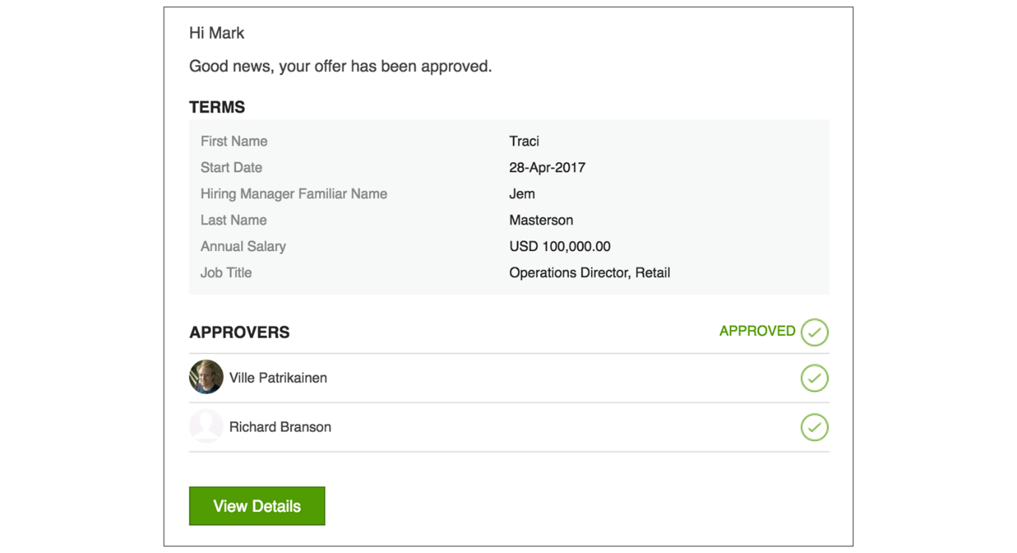
- Update the job's offer status details: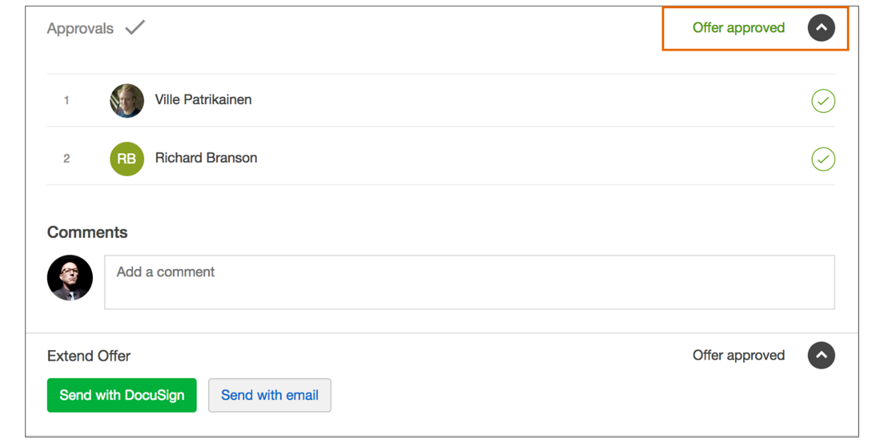
Note
Once the offer is approved, you can send it to the candidate via email or DocuSign, if your company has an active DocuSign integration.
Watch this video for a demo of how this process of creating offer approvals works.
This video is for demonstration purposes. Any references made in this video to previous or later videos in this course (including titles, numbers, links, or sequence) may differ from the current course structure. Additionally, some functionalities shown may have evolved over time due to ongoing enhancements or business decisions.
Summary
- Offer approval chains ensure proper oversight in the hiring process within SmartRecruiters.
- Approval chains can be customized based on organizational fields, allowing for tailored approval processes.
- SmartRecruiters offers sequential, parallel, and integration approval chain types to suit different organizational needs.
Hi, in this video, we're going
to review extending an offer with an offer approval chain and how
to set up an offer approval. Offer approvals ensure the right
amount of oversight in your hiring process. You have the option to
set up a single approval process for an entire company or multiple
processes for your offers under different brands, departments,
and locations, depending on your org field setup. Let's go
ahead and get started. Within your Settings panel, to open up the
Offer settings, you'll want to scroll down to the Configuration
section and click Offer approvals. In this setting, you have the
option to Create a new chain. You'll want to start by giving
your approval chain a name. As a reminder, it's a best
practice to use clean naming conventions to help you
organize the different approval chains that you'll end up
creating within your instance. Down below, you're presented
with an option to apply this approval chain to different org
fields. This is how you can allocate different approval chains to
different jobs within your system. For this example, I'm
going to go ahead and say that this approval chain is going to
apply to all of my org fields. However, as more approval chains
are created, you want to make sure that you apply these fields to be
unique of one another and align different approval chains to
different areas within your org. Once the org fields are applied, you'll
then create an approval chain. You can preset an approval chain
to be a sequential approval, meaning that the approval requests
are going to be sent in the order that you configure. Here,
a parallel approval, which will allow multiple approvers to
approve an offer at any given time. Or if you happen to be
leveraging an integration for your offer approvals, you
can select that as well. For this example, I'm going
to go ahead and say that this is a sequential approval,
again, meaning that every approver within the chain
has to approve the offer. You can select approvers.
They can be named users, any user within the hiring
process, or you can allocate specific hiring team roles to
be part of this approval chain. In this example, I'm going to go
ahead and make my admin user the approver on the chain. Once I'm satisfied with the approval chain, I can go ahead and save. You'll see now that the saved approval chain shows up on our details list and I can go ahead
and activate this approval chain. Now I expect to see this approval
chain apply to all of my offers. Other settings can be found in the
Offer approval settings and to be presented with three options. The
first setting we see here, Approver access to the offer, can be toggled
on or off. When a user is added to an approval chain, they're granted
full access to the job. If you choose to toggle this option on,
it will remove approver's access to the offer once the offer has
been approved. The delegate approver on the offer setting allows approvers
or an admin to delegate to another user. An example of this is if
you happen to have a user on an approval chain that happens to be
out of the office, let's say they're on a family vacation, you can
delegate the approval to another user. The authentication setting means
that users can access the offer approval without the need to be
authenticated into SmartRecruiters. All of these settings can be
toggled on or off as you see fit. Now that we've configured
our offer approval chain, let's go back to the candidate
we recently extended an offer and show how the offer approval
chain works. In the previous video, we extended an offer
without approval chains turned on. As you can see, now that
we're back in the Offers tab and our approval chain
is activated, we're met with a third step of setting
up an offer approval. Since I haven't sent this
offer to the candidate yet, the offer approval pulls in the
approval chain that I recently configured, and the named
user is the expected approver. If I wish, I can add comments on the approval request and
then send for approval. Since I'm the named user on the
approval chain, I can either approve or reject this approval and add
my comments for my reasoning. I'm going to go ahead
and approve this offer. Now that the offer is
approved, we can proceed with sending the offer to the candidate. Thank you.

